GAME DESIGN DOCUMENT

Tilted

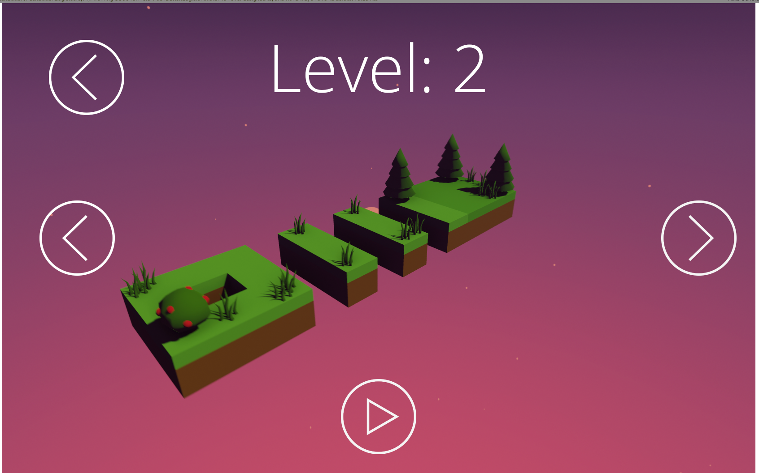

Golf without hitting balls

**Last Updated:**

7/6/20

**Prepared By:**

Marin Pavić

**TABLE OF CONTENTS**

Game Analysis 3

Mission Statement 3

Genre 3

Platforms 3

Storyline & Characters 3

Gameplay 4

Overview of Gameplay 4

Player Experience 4

Gameplay Guidelines 4

Gameplay Mechanics 4

Level Design 5

Control Scheme 6

Game Aesthetics & User Interface 6

# Game Analysis

Tilted is a game where you play gold, with a twist. You don’t move the ball, instead you tilt the entire course in order to “tilt” the ball to the hole. Game features platforming puzzles and low poly graphics.

# Mission Statement

You ever wanted to play golf, but you suck at hitting balls, what if you could just tilt the level so that the ball rolls by itself to the hole. Well now you can.

# Genre

Puzzle platformer

# Platforms

Windows, MacOS

# Storyline & Characters

A ball floating through space, lost in mysterious floating islands.

# Gameplay

## Overview of Gameplay

This game is similar to your regular golf games in its core gameplay loop, get the ball to the hole and you win, fall out of the course and you lose. The twist here is that you don’t hit the ball to get to the hole, you instead tilt the entire level to get the ball rolling down a hill to the hole. The player also has the ability to make the ball jump. Since the scoring can’t be done with traditional how many pars to the hole, it will be done using seconds to complete and the number if “tilt” attempts the player made.

## Player Experience

First booting up the game, apart from the main menu the player will be able to select levels to play. After selecting a level the player can attempt to beat it. When failing to beat the level (fall off the course) the player has the option to try again or exit to the level picker. If the player wins, he is shown his winning time and tilts and can proceed to the next level.

## Gameplay Guidelines

The game has to have low poly aesthetic throughout the visuals, that includes: fonts, lighting, graphics, music… Extra steps have to be taken to ensure that the new piece of art fits with the games art and feel style.

## Gameplay Mechanics

|  |  |
| --- | --- |
| Character Attributes |  |
| Character | Movement Abilities / Actions Available |
| Ball | Can jump to get over obstacles |
| Course | Can be tilted in full 6 degrees of freedom |
|  |  |
| Game Modes |  |
| Golf | Player has to get the ball to the hole. The Course has to guard rails so the ball can fall of the course, resulting in a game over |
| Scoring System |  |
| Points/Coins/Stars/Grades/Etc. | How it’s Awarded & Benefits |
| Time | Player is timed during gameplay, after finishing the course if his time is over a certain threshold, he is rewarded with completion checkmark on that level, if not he can still move to the next level but without a checkmark that he completed a level |
| Tilts | Every attempt at a level tilt (e.g. Press of W, A, S or D) results in a tilt counter counting up by one, after the level is complete, the player is shown the number of tilts it took to finish the level |

## Level Design

The game currently has 3 levels and the design fits with the low poly, simple graphics. Levels are block based, similar to something like Minecraft with its own unique theme. The level design also fits the platforming aspect of the game.

|  |  |
| --- | --- |
| Levels |  |
|  | Simple level to teach the player the controls |
|  | A little bit more advanced level to teach the player that the ball can jump |
|  | An advanced level for the player to test his/her skills |

# Control Scheme

Game can be played with a Mouse and Keyboard and Controller

|  |  |
| --- | --- |
| Button/ Touch Input | Action it Performs |
| W, S, A, D, d-pad, Left analog | Rotate the level. |
| A, X, Space | Make the ball jump |

# Game Aesthetics & User Interface

Game has a Low poly design with a space vibe